|  |  |  |
| --- | --- | --- |
| **A**  **PROJECT REPORT ON** | | |
|  | | |
|  | | |
| Green-Grocers  Online Vegetable Shop | | |
|  | | |
|  | | |
| SUBMITTED IN  PARTIAL FULFILLMENT OF  **DIPLOMA IN ADVANCED COMPUTING (PG-DAC)** | | |
|  | | |
|  | | |
|  | | |
|  | | |
|  | | |
|  | | |
|  | | |
| **BY**  **Shivshankar Yashwant Patil** | | |
|  | | |
|  | | |
| **UNDER THE GUIDENCE OF**  **Rugveda Kulkarni** | | |
|  | | |
|  | | |
|  | | |
| **AT**  **SUNBEAM INSTITUTE OF INFORMATION TECHNOLOGY,**  **PUNE** | | |
|  | |
| **SUNBEAM INSTITUTE OF INFORMATION TECHNOLOGY,**  **PUNE.** | |
|  | |
|  | |
|  | |
|  | |
| **CERTIFICATE** | |
|  | |
| This is to certify that the project | |
|  | |
| Green-Grocers  Online Vegetable Shop | |
|  | |
| Has been submitted by | |
|  | |
| **Shivshankar Yashwant Patil** | |
|  | |
|  | |
| In partial fulfillment of the requirement for the Course of **PG Diploma in Advanced Computing (PG-DAC AUG2015)** as prescribed by The **CDAC** ACTS, PUNE. | |
|  | |
|  | |
| Place: Karad | Date: 19-Feb-2024 |
|  | |
|  | |
|  | |
|  | |
|  | |
| **Rugveda Kulkarni** | **<Alumni Mentor Name>** |
| **Project Guide** | **Alumni Mentor** |

**ACKNOWLEDGEMENT**

A project usually falls short of its expectation unless aided and guided by the right persons at the right time. We avail this opportunity to express our deep sense of gratitude towards **Mr. Prashant Lad (Center Coordinator, SIIT, Karad)** and **Mr. Pratik Ninganur (Course Coordinator, SIIT, Karad)**.

We are deeply indebted and grateful to them for their guidance, encouragement and deep concern for our project. Without their critical evaluation and suggestions at every stage of the project, this project could never have reached its present form.

Last but not the least we thank the entire faculty and the staff members of Sunbeam Institute of Information Technology, Karad for their support.

Shivshankar Yashwant Patil

Roll No: 80220

PRN: 230940820074

**ABSTRACT**

The GreenGrocers project aims to develop a comprehensive and user-friendly online platform for purchasing fresh and quality vegetables. In the fast-paced digital era, consumers are increasingly turning to online platforms for their daily needs, and the demand for convenient and reliable online vegetable shopping experiences is on the rise. GreenGrocers seeks to bridge this gap by providing a robust e-commerce solution tailored specifically for the vegetable market.

The platform will offer a diverse range of fresh vegetables sourced directly from local farmers and trusted suppliers. Users will have access to an extensive catalog featuring a variety of vegetables, allowing them to make informed choices based on preferences, nutritional information, and pricing. The system will incorporate a user-friendly interface that ensures a seamless and enjoyable shopping experience.

Key features of the GreenGrocers project include:

1. User Registration and Authentication:

2. Intuitive User Interface:

3. Product Catalog:

4. Shopping Cart and Checkout:

5. Order Tracking:

6. Vendor Management:

7. Feedback and Rating System:

8. Responsive Design:

By implementing these features, GreenGrocers aims to revolutionize the online vegetable shopping experience, promoting sustainable practices, supporting local farmers, and providing consumers with a convenient and reliable source of fresh, quality produce. This project contributes to the growing trend of digitizing traditional markets and fostering a healthier and more connected community.

**INDEX**

|  |  |  |
| --- | --- | --- |
|  | **INTRODUCTION** | 7 |
|  | 1.1 Introduction | 7 |
|  | **Product Overview and Summary** | 8 |
|  | 2.1 Purpose | 8 |
|  | 2.2 Scope | 8 |
|  | 2.3 User Classes and Characteristics | 8 |
|  | 2.4 Design and Implementation Constraints | 9 |
|  | **REQUIREMENTS** | 10 |
|  | 3.1 Functional Requirements | 10 |
|  | 3.1.1 Use case for Administrator. | 11 |
|  | 3.1.2 Use case for Customer. | 11 |
|  | 3.2 Non - Functional Requirements | 12 |
|  | 3.2.1 Usability Requirement | 12 |
|  | 3.2.2 Performance Requirement | 12 |
|  | 3.2.3 Reliability Requirement | 12 |
|  | 3.2.4 Portability Requirement | 13 |
|  | 3.2.5 Security Techniques | 13 |
|  | **PROJECT DESIGN** | 14 |
|  | 4.1 Data Model | 14 |
|  | 4.1.1 Database Design | 14 |
|  | 4.2 Process Model | 15 |
|  | 4.2.1 Functional Decomposition Diagram | 15 |
|  | 4.2.2 Data Flow Diagram (DFD) | 16 |
|  | **TEST REPORT** | 17 |
|  | **PROJECT RELATED STATISTICS** | 19 |
|  | **CONCLUSION** | 20 |

**LIST OF TABLES**

|  |  |  |
| --- | --- | --- |
| **Section** | **Table Title** | **Page** |
| **5** | **Test Report** | 17 |
|  |  |  |

**LIST OF FIGURES**

|  |  |  |
| --- | --- | --- |
| **Section** | **Figure Title** | **Page** |
| **3** | **Use Case Diagram for users** | 11 |
| **3** | **Use Case Diagram for admin** | 11 |
| **4.1** | **E-R diagram** | 14 |
| **4.2.1** | **Function Decomposition Diagram** | 15 |
| **4.2.2** | **Data Flow Diagram** | 16 |
| **6** | **Project Related Statistics** | 19 |
|  |  |  |
|  |  |  |
|  |  |  |
|  |  |  |
|  |  |  |
|  |  |  |

**INTRODUCTION**

* 1. **Introduction**

In a world where convenience and efficiency have become integral aspects of daily life, the demand for accessible and reliable online platforms for essential needs has grown significantly. The GreenGrocers project emerges as a solution to address this demand, focusing specifically on revolutionizing the online vegetable shopping experience.

Traditional vegetable shopping often involves time-consuming visits to local markets, uncertain quality, and limited choices. GreenGrocers recognizes the need for a modern solution that not only caters to the convenience of online shopping but also ensures access to fresh and high-quality vegetables sourced directly from local farmers. By bridging the gap between consumers and farmers, the project aims to create a sustainable and mutually beneficial ecosystem.

The primary objective of GreenGrocers is to provide a seamless, reliable, and enjoyable online platform for users to purchase fresh vegetables. The project seeks to empower consumers by offering a diverse catalog of vegetables along with detailed information to make informed decisions. Simultaneously, it strives to support local farmers and suppliers by creating a direct channel to reach consumers, fostering transparency, and promoting sustainable agricultural practices.

GreenGrocers incorporates a range of key features to enhance the overall online vegetable shopping experience. These include user-friendly interfaces, an extensive product catalog, and real-time order tracking. The project places a strong emphasis on vendor management, ensuring a direct link between users and local farmers, thereby promoting community engagement and sustainable business practices.

**PRODUCT OVERVIEW AND SUMMARY**

**2.1 Purpose**

The purpose of the GreenGrocers project is to establish an innovative and user-centric online platform for vegetable shopping, addressing the growing demand for convenient, reliable, and sustainable solutions. By connecting consumers directly with local farmers and trusted suppliers, GreenGrocers aims to revolutionize the vegetable market, offering a diverse range of fresh produce, fostering community engagement, and promoting sustainable agricultural practices. This project seeks to enhance the overall online shopping experience while contributing to the well-being of both consumers and local farmers.

**2.2 Scope**

The GreenGrocers project encompasses the development and implementation of a user-friendly online vegetable shopping platform. The scope includes creating a robust e-commerce system with features such as secure user authentication, an intuitive interface, a comprehensive product catalog, efficient shopping cart and checkout processes, real-time order tracking, and a vendor management system. The platform aims to connect consumers directly with local farmers, ensuring a direct and reliable source of fresh vegetables. The primary focus is on providing a seamless and enjoyable online vegetable shopping experience while supporting local farmers and promoting sustainable agricultural practices.

**2.3 User Classes and Characteristics**

**1. Users:**

* Characteristics: Individuals seeking convenient and reliable access to fresh vegetables.
* Behaviour: Place orders, explore product catalog, provide feedback, and track orders.

**2. Seller:**

* Characteristics: Local farmers and suppliers providing fresh produce.
* Behaviour: Create vendor profiles, manage product listings, fulfil orders.

**3. Delivery Boy:**

* Characteristics: Delivery Boys assigned by Sellers.
* Behaviour: Deliver the orders to the particular user.

**4. Admin:**

* Characteristics: Admin for reviewing all the user classes.
* Behaviour: Check the users, sellers, and delivery boys.

**2.4 Design and Implementation Constraints**

Design and Implementation Constraints:

1. Technology Compatibility:

Constraint: Compatibility with various devices and browsers may pose challenges, requiring responsive design for optimal user experience across platforms.

2. Data Security and Privacy:

Constraint: Strict adherence to data protection regulations and the implementation of robust security measures to safeguard user information.

3. Internet Accessibility:

Constraint: Dependence on internet connectivity for users, potentially limiting access for those in areas with unreliable or limited internet infrastructure.

4. Vendor Onboarding:

Constraint: The process of onboarding local farmers and suppliers may face challenges in terms of technology adoption and information sharing.

5. Scalability:

Constraint: Ensuring the platform's scalability to accommodate potential growth in user base and transaction volume, requiring careful planning and resource allocation.

6. User Education:

Constraint: The need for user education to familiarize both consumers and farmers with the platform's features and processes, influencing adoption rates.

Recognizing and addressing these constraints during the design and implementation phases is crucial to the successful development and deployment of the GreenGrocers platform. Strategies such as thorough testing, compliance checks, and user training can help mitigate potential challenges and ensure the platform's effectiveness in meeting its objectives.

**REQUIREMENTS**

**3.1 Functional Requirements**

**1. Registration and Authentication:**

Users, Sellers, Delivery Boys can create accounts with secure authentication.

**2. Product Catalog:**

Comprehensive catalog with required information and images.

**3.Shopping Cart and Checkout:**

Users can add, and review items in their shopping carts.

4. **Vendor Management:**

Farmers and suppliers can create and manage profiles. Ability to add new products.

**5. Order Tracking:**

User can see the status of his orders i.e. pending, shipped and completed.

**6. Responsive Design:**

Platform is accessible on various devices.

**7. Account Management:**

Users, Sellers and Delivery Boys can manage i.e. update their personal details.

**8. Security Measure:**

Added spring security for users for authorizing and authenticating users. Used JwtToken for security measures.

**9. Educational Resources:**

Provision of user guides or tutorials for platform education.

**3.1.1 Use case for user:**

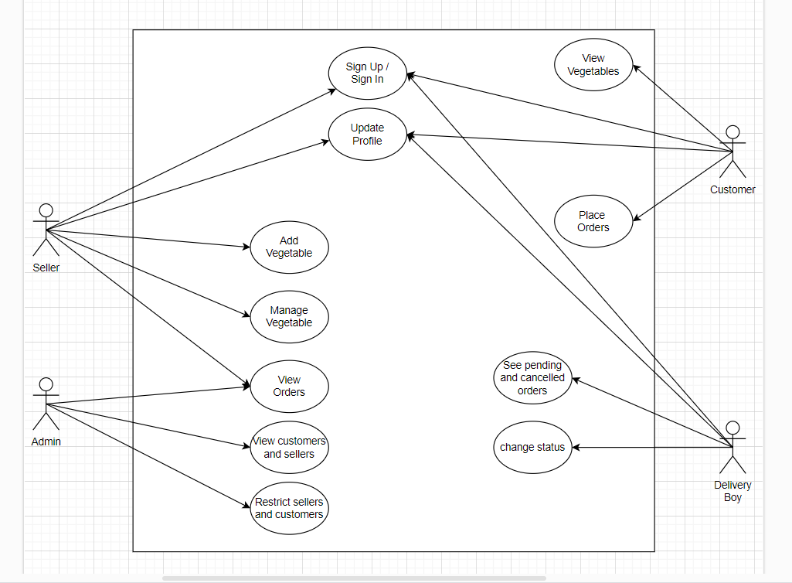

**Fig 3.1.1: Use Case Diagram for User**

**3.1.2 Use case for Administrator:**

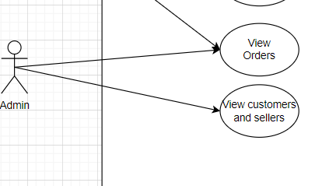

**Fig 3.1.2: Use Case for administrator**

**3.2 Non - Functional Requirements**

**3.2.1 Usability Requirement:**

1. **Intuitive Navigation: T**he platform should offer an easy-to-navigate interface for users to browse products effortlessly.

2. **User-Friendly Design:** The design should be visually appealing, ensuring a positive and enjoyable shopping experience.

3. Product Information: Product listings should include detailed descriptions and high-quality images for informed decision-making.

4. **Smooth Shopping Cart Interaction:** Users should be able to add and review items in their shopping carts seamlessly.

5. Real-Time Order Tracking: User can see the status for his order status.

**3.2.2 Performance Requirement:**

1. **Transaction Processing Time:** The platform should process transactions, including order placement within 5 seconds.

2. **Scalability:** The system should handle a simultaneous user load of at least 1000 users without significant performance degradation.

3. **Database Response Time:** Database queries should be optimized to provide responses within 2 seconds for efficient data retrieval.

**3.2.3 Reliability Requirement**

1. Data Integrity: Data integrity checks should be implemented to prevent data corruption, ensuring the accuracy and reliability of stored information.

2. Fault Tolerance: The system should be designed with fault-tolerant features to continue operation in the presence of hardware or software failures.

3. User Account Reliability: User accounts and profiles should be reliable, with secure authentication methods to prevent unauthorized access or account compromise.

**3.2.4 Portability Requirement**

1. Cross-Browser Compatibility: The platform should be compatible with major web browsers, including Google Chrome, Mozilla Firefox, Safari, and Microsoft Edge.

2. **Device Compatibility:** GreenGrocers should be accessible and functional on various devices, such as smartphones, tablets, and desktop computers.

3. Operating System Independence: The platform should operate seamlessly across different operating systems, including Windows, macOS, and Linux.

4. Responsive Design: The user interface should dynamically adjust to different screen sizes and resolutions for a consistent and user-friendly experience.

5. Third Party Integration: GreenGrocers should integrate with external services or APIs without significant modification, ensuring adaptability to future enhancements or changes in third-party services.

**3.2.5 Security Techniques**

1. Authentication Management: Implement a robust authentication system with secure password policies and options for multi-factor authentication.

2. User Privacy: Ensure compliance with data protection regulations, and clearly communicate the platform's privacy policy to users.

3. User Session Management: Implement secure session management practices, including session timeouts and secure session handling.

**PROJECT DESIGN**

**4.1 Data Model**

**4.1.1 Database Design**

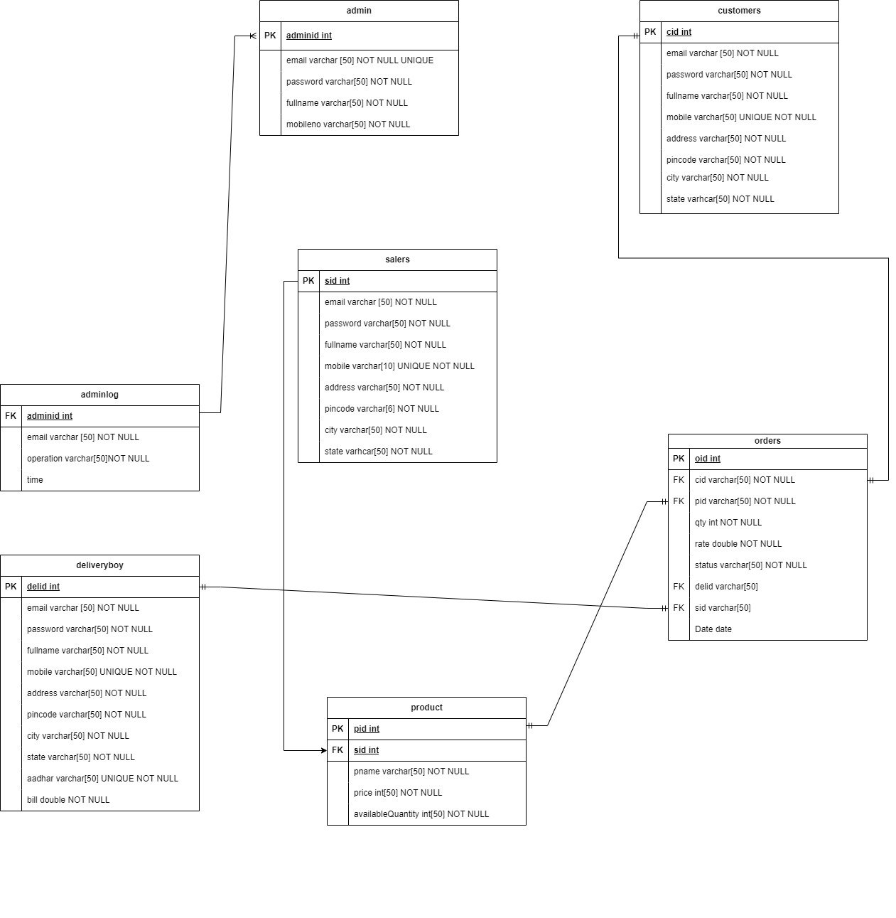

**Fig 4.1.1: E-R Diagram**

**4.2 Process Model**

**4.2.1 Functional Decomposition Diagram:**

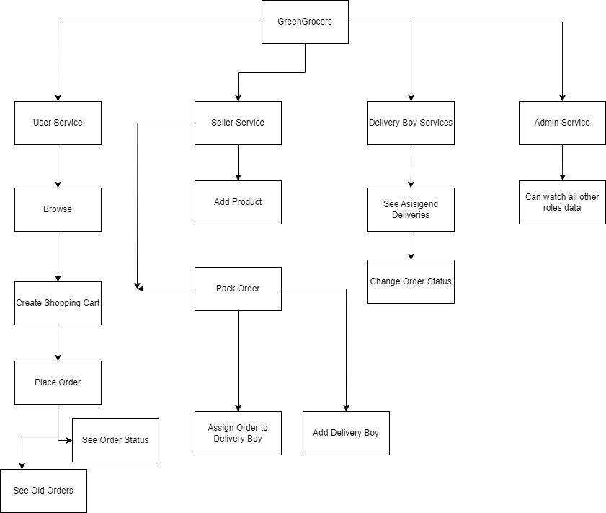

**Fig 4.2.1: Function Decomposition Diagram**

**4.2.2 Data Flow Diagram (DFD)**

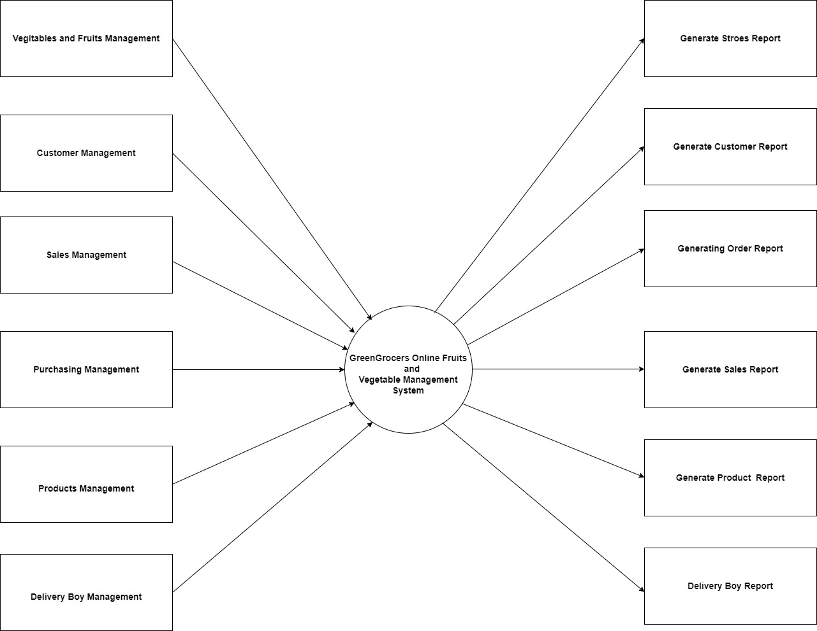

**Fig 4.2.2: Data Flow Diagram**

**TEST REPORT**

**We have performed unit testing for testing the application. For performing the unit testing, we individually tested each unit like login, registration, user/seller/delivery boy functionality for the application.**

|  |  |  |  |  |  |
| --- | --- | --- | --- | --- | --- |
| Sr.no | Test Case | Expected  Result | Actual Result | Error Message | Type Of  Error |
| 1 | Login For User, Seller, Delivery Boy and Admin | Redirection to respective Dashboards | Redirection to respective roles Dashboard pages | Invalid Username or Password in case of wrong inputs | Minor |
| 2 | Registration for User | Email sent to valid email and redirection for otp verification | Email received to user end and redirection to next otp verification page. | No further redirection till valid otp is entered | Minor |
| 3 | Registration for seller, delivery boy and admin | After successful registration redirection to login page | Redirected to Login pages of respective role | No error | Minor in case of password length |
| 4 | User adds product to bucket/cart and then places the delivery | All the items added to cart must be displayed with total bill amount. Order will be placed and bucket/ cart is emptied. | Total bill amount and items added to cart are shown.  Order is shown in my orders and status is shown as “pending”. | No error | Minor |
| 5 | Seller adds available products in shop. | Products with image and other details are added and displayed on dashboard | Products added to the product table of the seller | Error if image address size is large | Minor |
| 6 | Seller assigns order to delivery boy | Status of order is changed to “shipped” and order assigned to delivery Boy | Status changed to “pending” and delivery boy will be able to see orders assigned to him. | No error | Minor |
| 7 | Delivery Boy completes order after delivering | Status of order changed to “Completed” and assigned order is removed from tasks of delivery boy. | Order status changes to “Completed” and pending orders are removed from table | No error | Minor |
| 8 | Admin Dashboard | Admin is able to see total count of sellers, users, delivery boys and number of products on application | Count of users, sellers, delivery boys and products is displayed on admin dashboard | No error | Minor |
| 9 | Log out (for all) | Redirection to common page for login | Common page for login and signup is shown | No error | Minor |

**PROJECT RELATED STATISTICS**

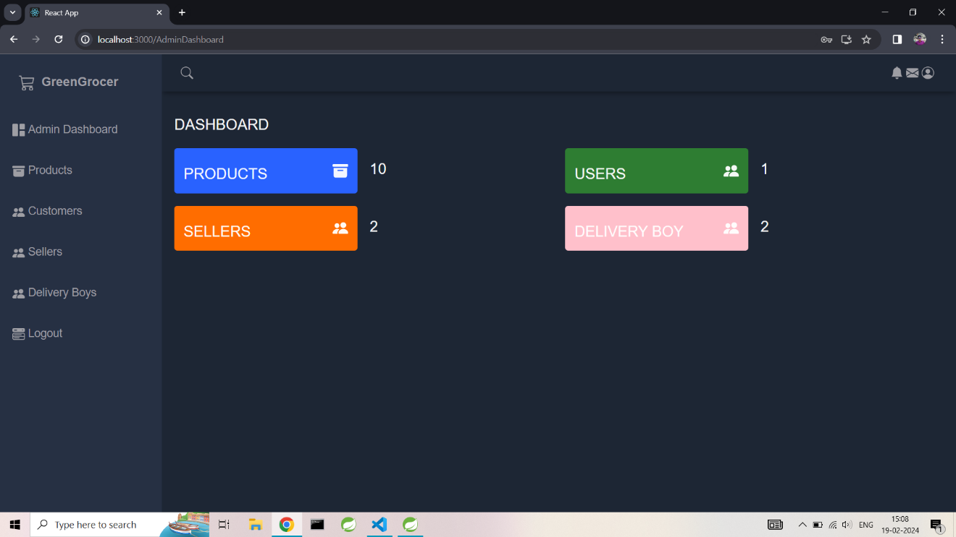

**Fig 6: Project Related Statistics**

**CONCLUSION**

In conclusion, the GreenGrocers project endeavours to redefine the online vegetable shopping experience by creating a user-friendly platform that connects consumers directly with local farmers. Through intuitive design, real-time tracking, and a comprehensive product catalog, GreenGrocers aims to provide convenience, transparency, and support for sustainable agricultural practices. By fostering community engagement and adhering to stringent security and usability standards, GreenGrocers aspires to be more than just an online marketplace, but a catalyst for positive change in the way we source and consume fresh produce.